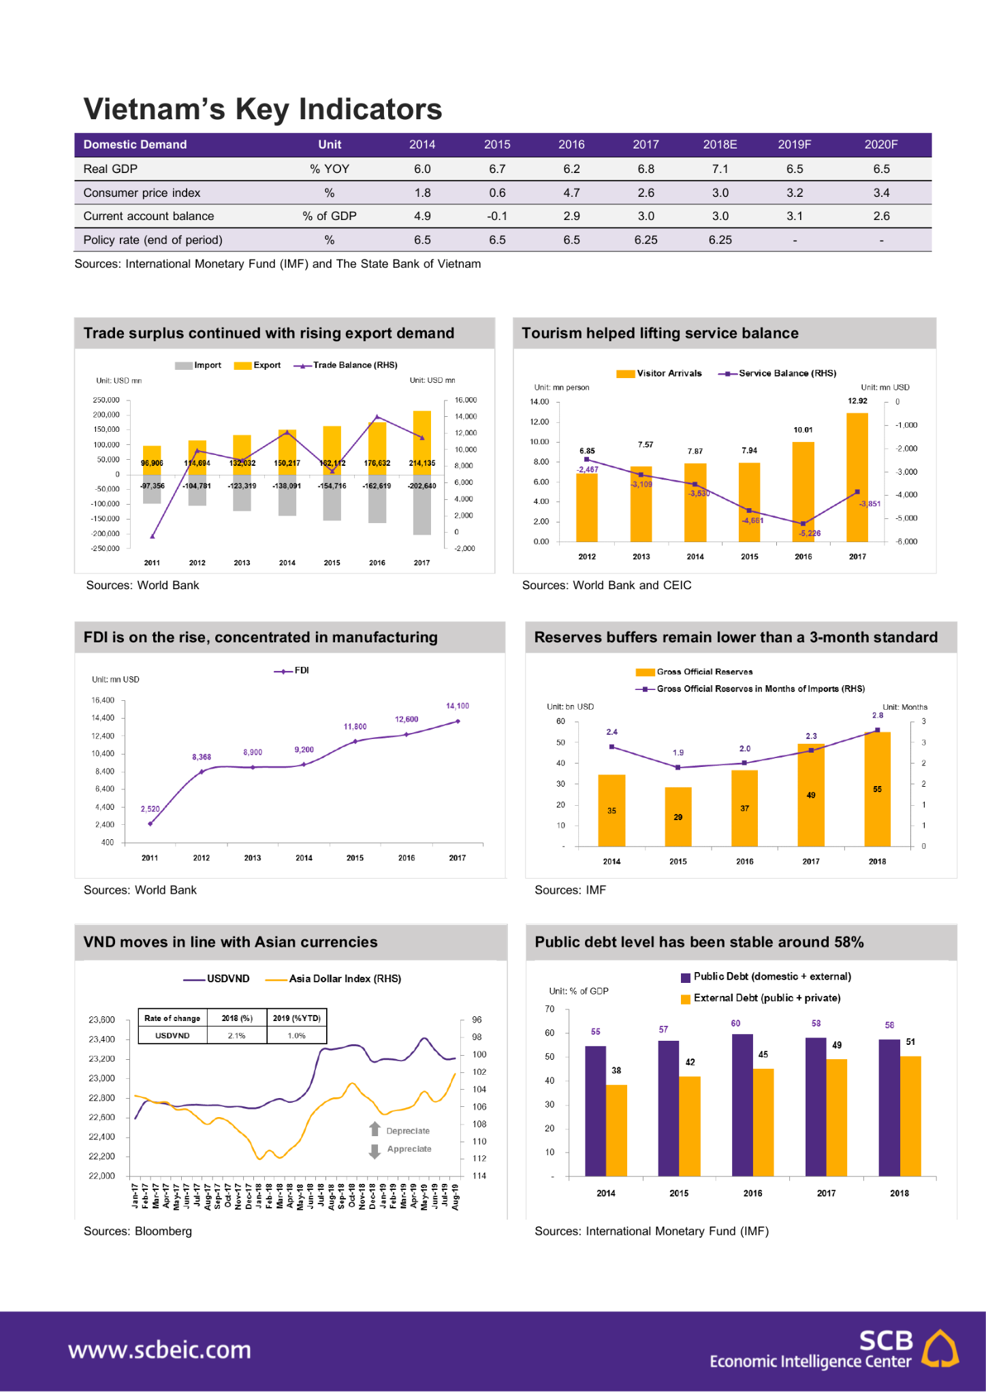
Based on the input image and the specific text output you provided, here is the detailed cost calculation for this single inference using Gemini 3 Pro.

Cost Summary
- Total Estimated Cost: $0.0048 USD (approx. half a cent)
- Breakdown: ~12% for the image input, ~88% for the text generation.

Detailed Breakdown

1. Input Cost (The Image)
The model converts the image into "tokens" to process it.
- Image Token Count: 560 tokens (Fixed rate for Gemini 3 Pro high-res mode).
- Input Price: $1.00 per 1 million tokens.
- Calculation: $(560 / 1,000,000) \times \$1.00$
- Input Cost: $0.00056

2. Output Cost (The Generated Text)
The cost depends on how much text the model wrote. The output you provided contains formatted tables and HTML, which increases the token count.
- Character Count: Approximately 2,800 characters (including HTML tags).
- Estimated Token Count: ~700 tokens (using the standard estimation of ~4 characters per token).
- Output Price: $6.00 per 1 million tokens.
- Calculation: $(700 / 1,000,000) \times \$6.00$
- Output Cost: $0.0042

Total Calculation
$$0.00056 \text{ (Input)} + 0.0042 \text{ (Output)} = \mathbf{\$0.00476}$$
Note: The prompt text instructions (e.g., "Please extract this...") would add a negligible fraction (approx. $0.00005) to the input cost, which does not materially change the final total.
Next Step: Would you like to see how this cost compares if you were to process a batch of 1,000 such documents?

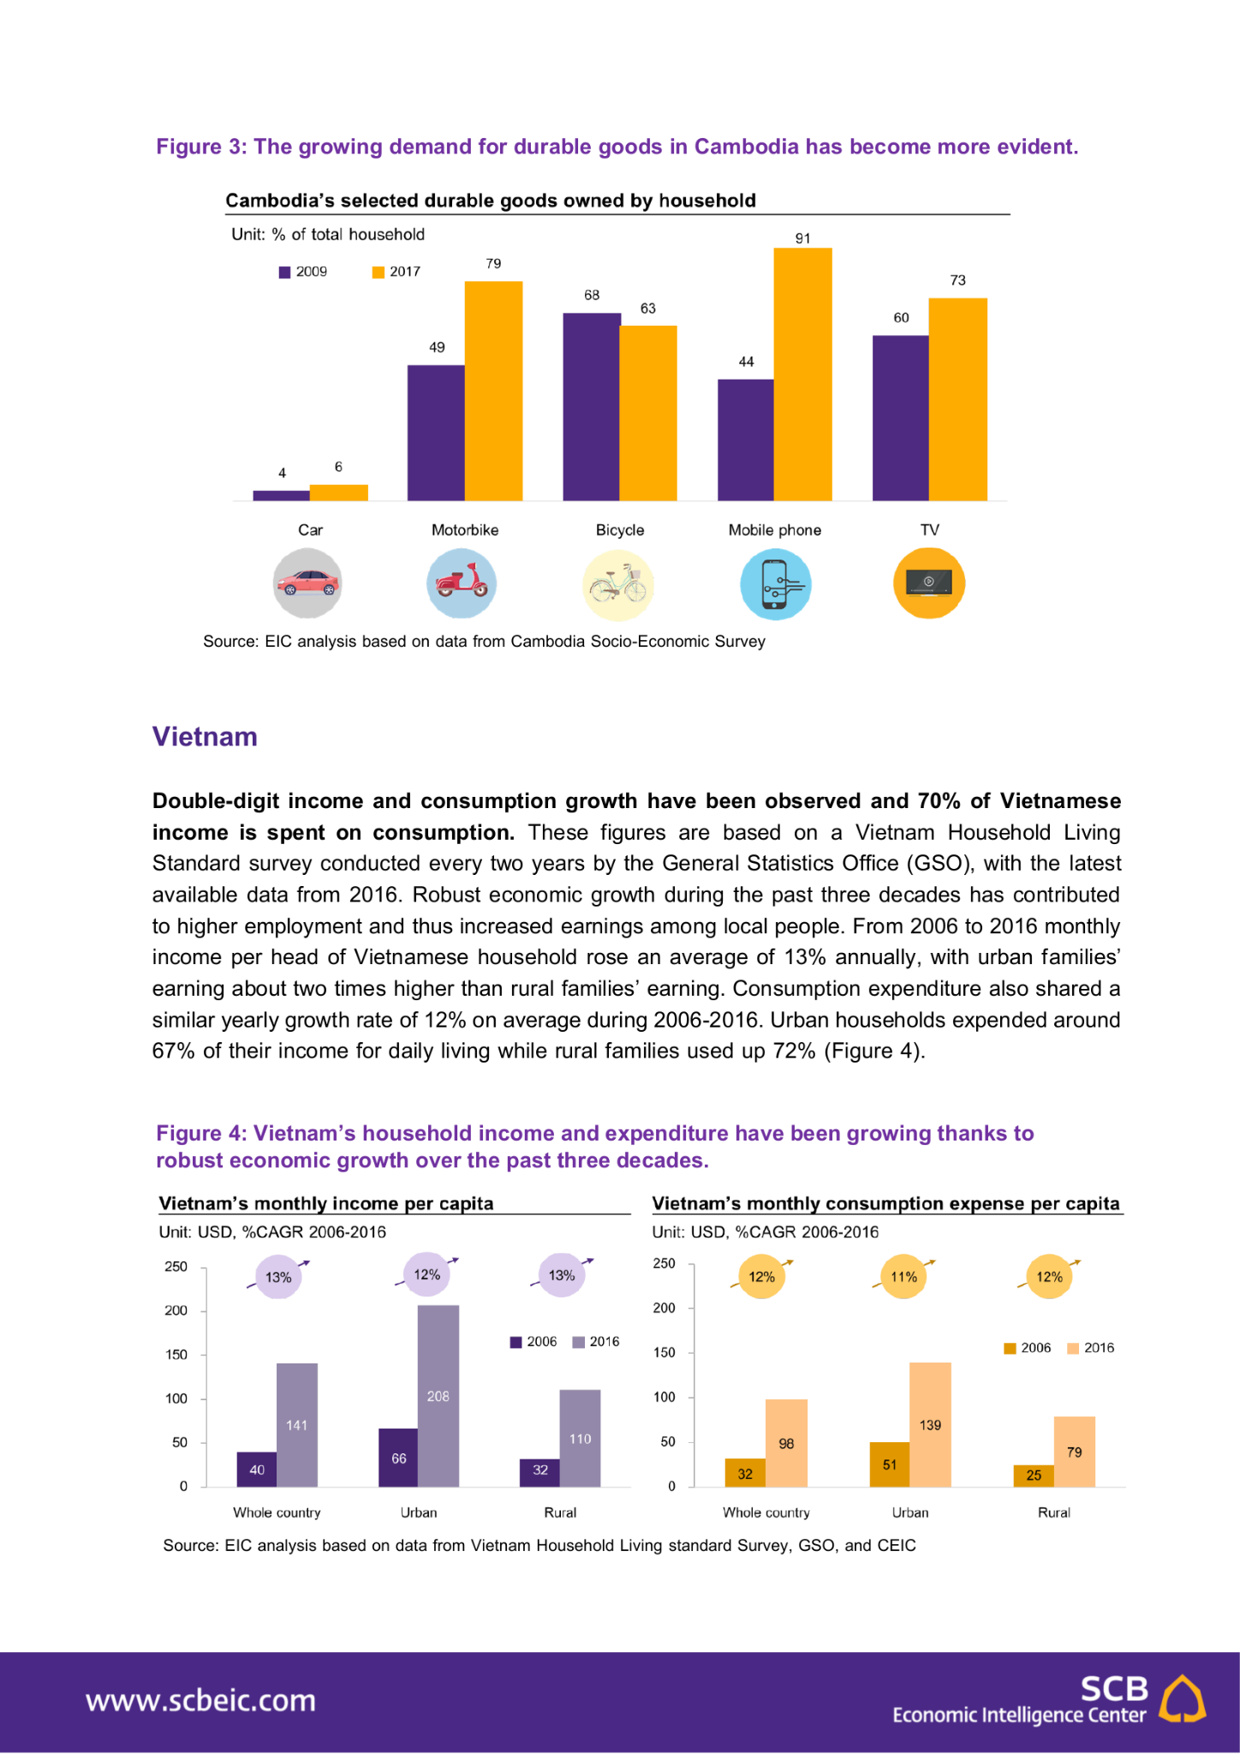
Based on the input image (CLMV_Q3_2019_EN_external_page24.jpg) and the text output you provided, here is the cost calculation for this specific inference using Gemini 3 Pro.

Cost Summary
- Total Estimated Cost: $0.0039 USD (approx. 0.4 cents)
- Breakdown: ~15% for the image input, ~85% for the text generation.

Detailed Breakdown

1. Input Cost (The Image)
- Image Token Count: 560 tokens (Standard high-res image cost for Gemini 3 Pro).
- Input Price: $1.00 per 1 million tokens.
- Calculation: 560 / 1,000,000 × $1.00
- Input Cost: $0.00056

2. Output Cost (The Generated Text)
The output includes one long paragraph and three formatted HTML tables.
- Output Content: Approx. 2,000 characters (including HTML tags for the tables).
- Estimated Token Count: ~550 tokens.
- Output Price: $6.00 per 1 million tokens.
- Calculation: 550 / 1,000,000 × $6.00
- Output Cost: $0.00330

Total Calculation
$$0.00056 \text{ (Input)} + 0.00330 \text{ (Output)} = \mathbf{\$0.00386}$$
Would you like me to estimate the monthly cost if you were to automate this extraction for a specific number of reports per month?

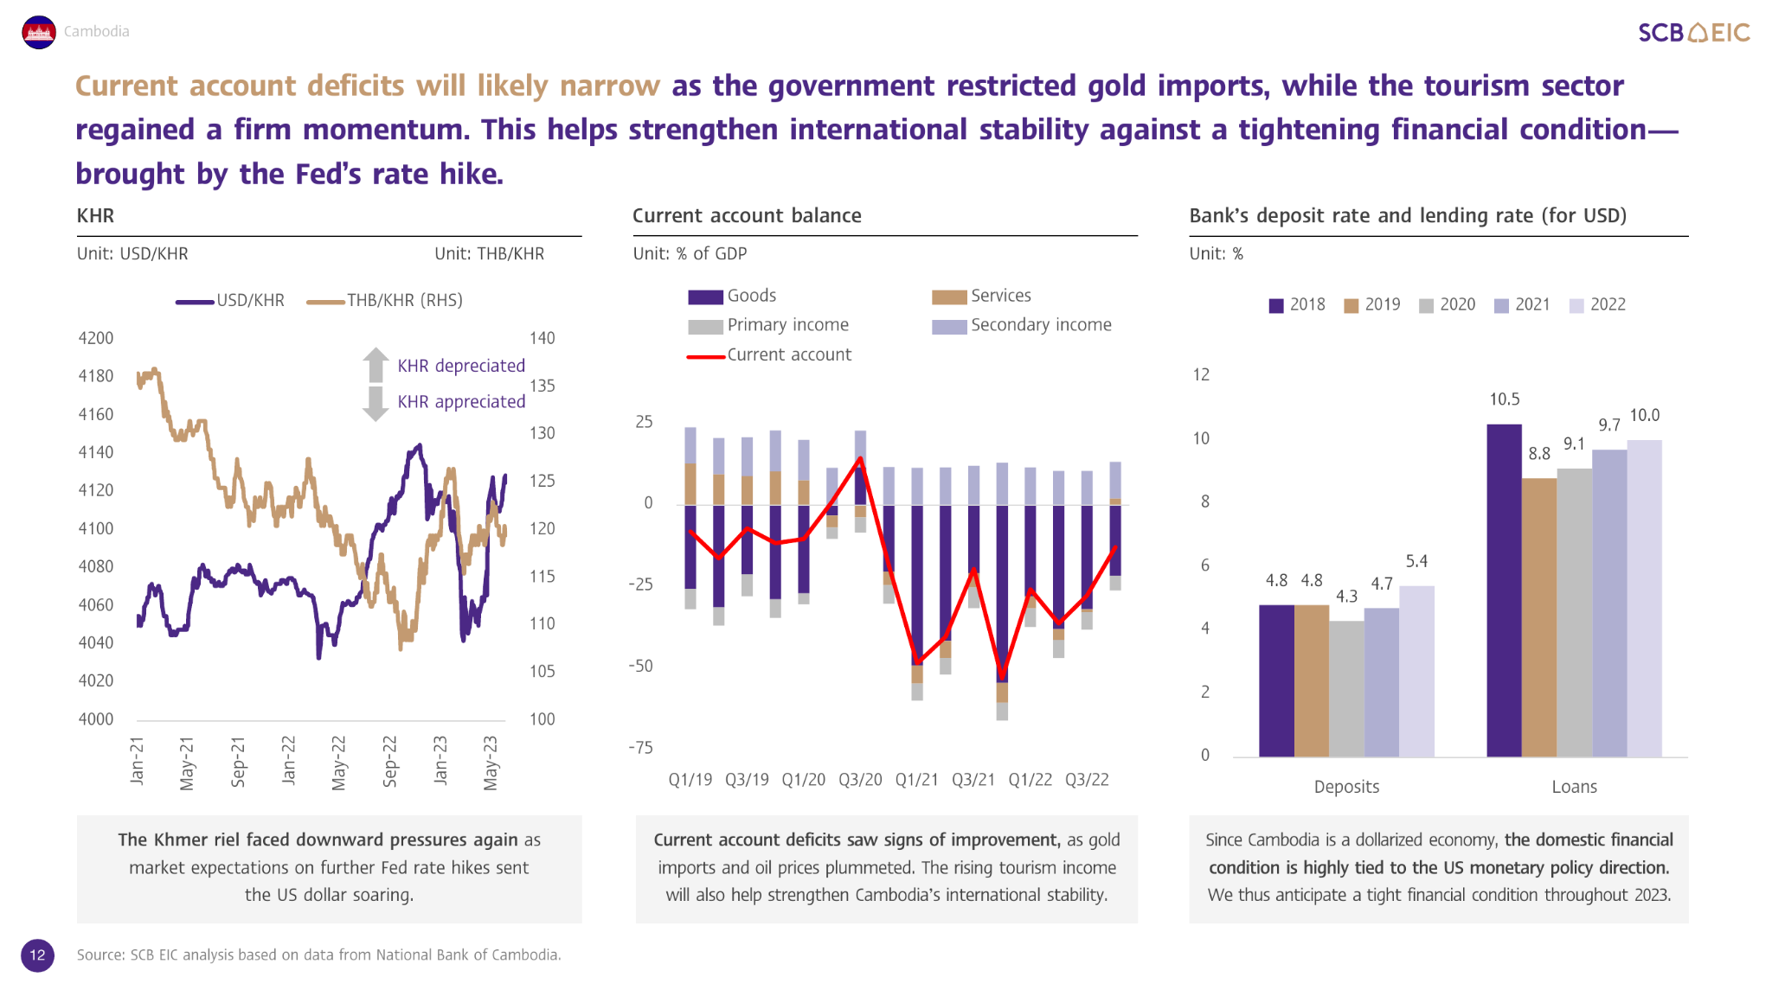

Based on the input image (CLMV-Outlook-July-2023_EN_20230811_page12.jpg) and the text output you provided, here is the cost calculation for this specific inference using Gemini 3 Pro.

Cost Summary
- Total Estimated Cost: $0.0054 USD (approx. half a cent)
- Breakdown: ~10% for the image input, ~90% for the text generation.

Detailed Breakdown

1. Input Cost (The Image)
- Image Token Count: 560 tokens (Standard high-res image cost for Gemini 3 Pro).
- Input Price: $1.00 per 1 million tokens.
- Calculation: $560 / 1,000,000 \times \$1.00$
- Input Cost: $0.00056

2. Output Cost (The Generated Text)
The output includes HTML tables and descriptive analysis, which increases the token count compared to plain text.
- Output Content: Approximately 3,200 characters (including HTML table tags).
- Estimated Token Count: ~800 tokens.
- Output Price: $6.00 per 1 million tokens.
- Calculation: $800 / 1,000,000 \times \$6.00$
- Output Cost: $0.00480

Total Calculation
$$0.00056 \text{ (Input)} + 0.00480 \text{ (Output)} = \mathbf{\$0.00536}$$
Next Step: Would you like to know how much it would cost to process all 4 of your uploaded images with this level of detailed output?

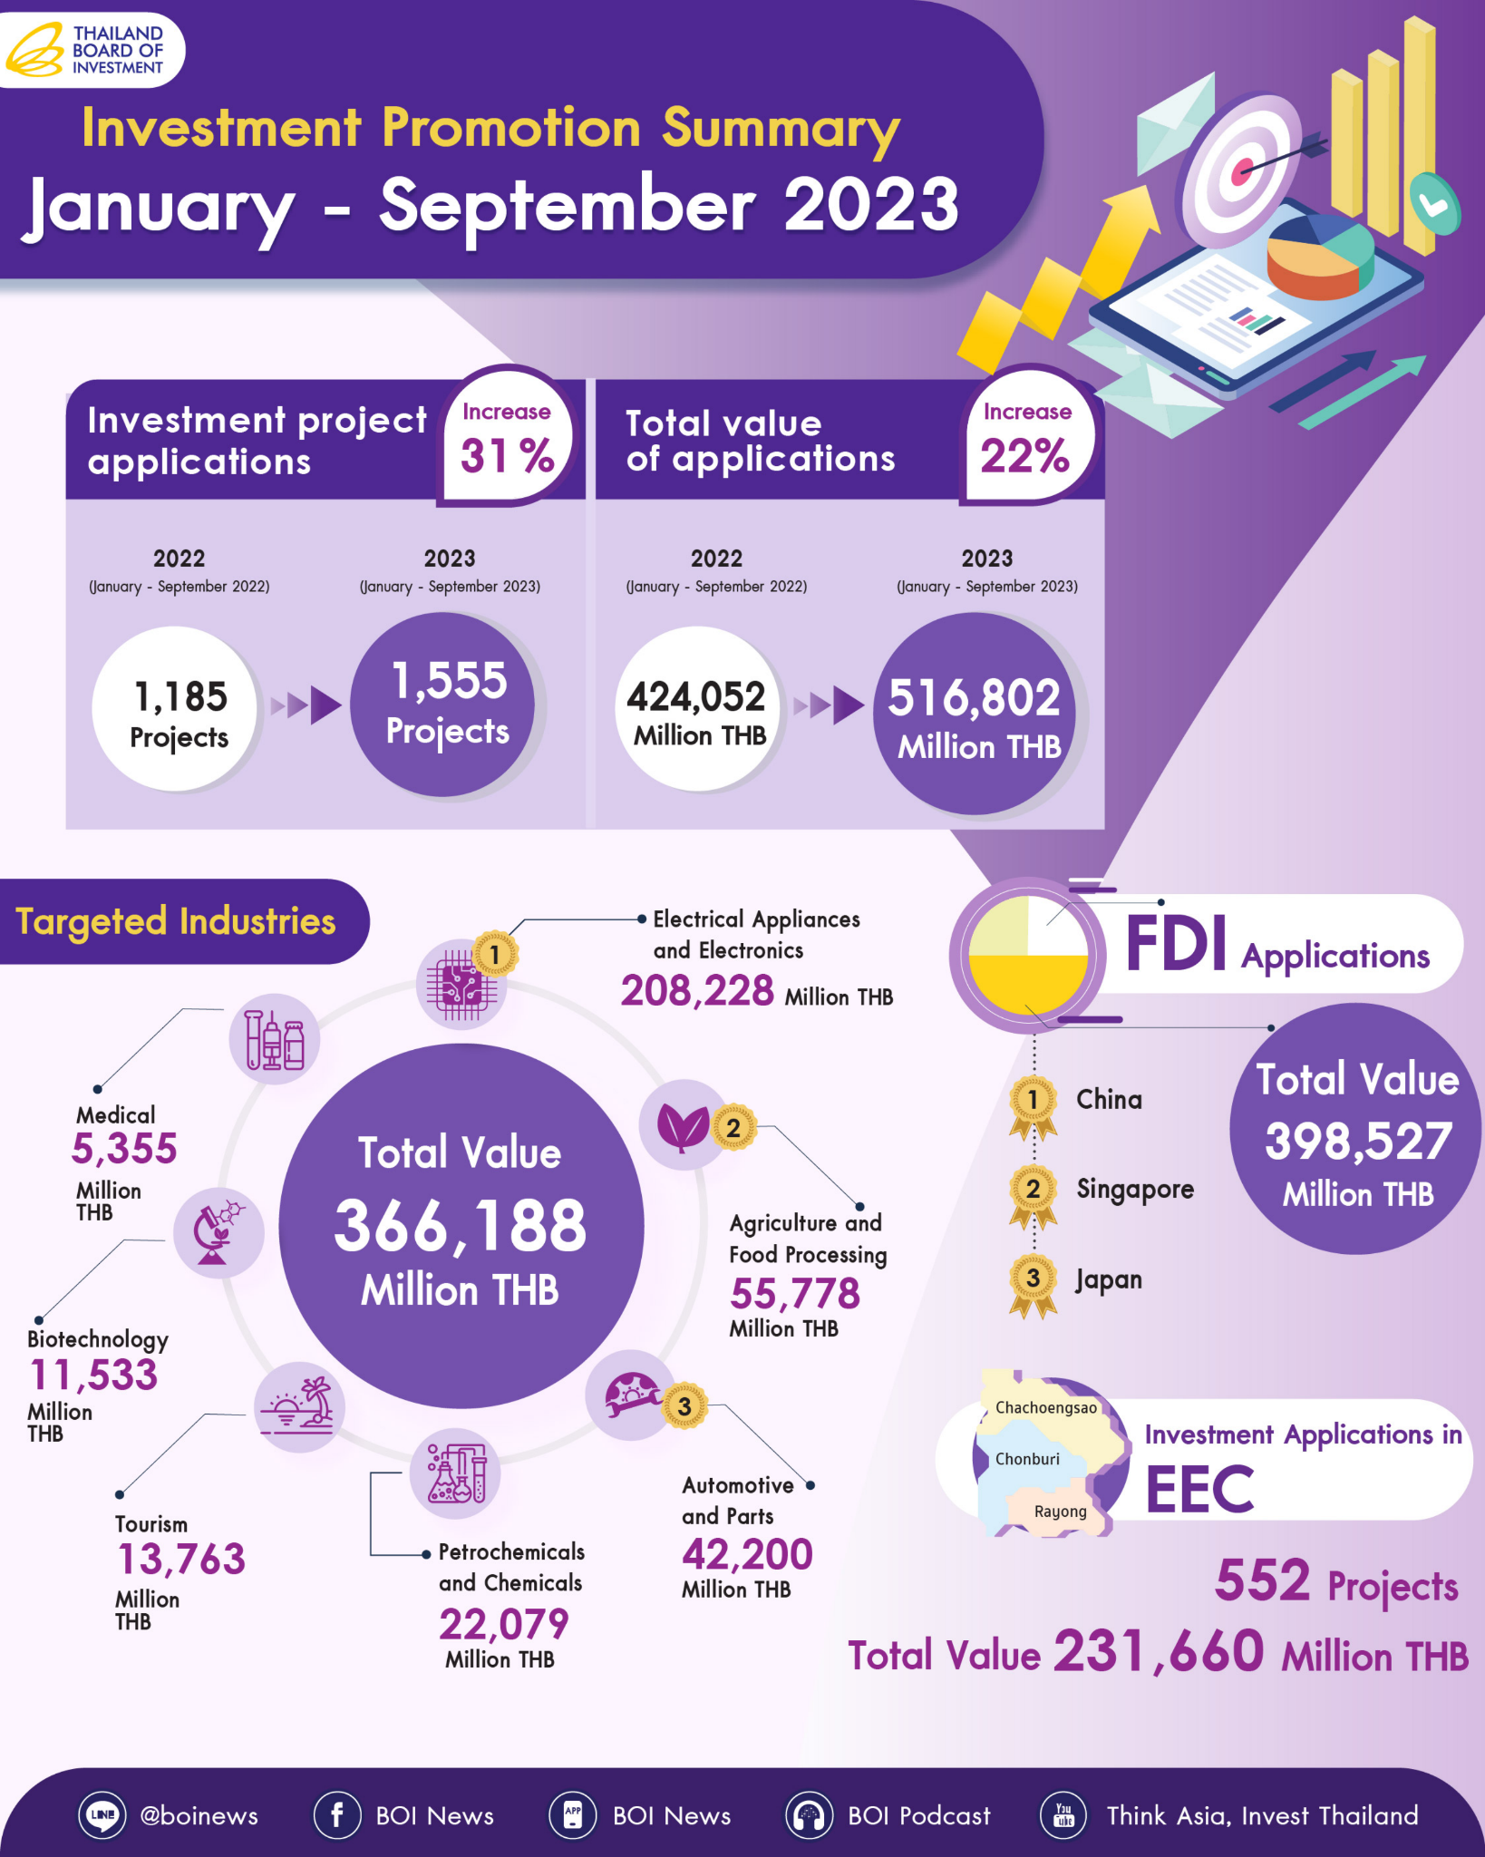

Based on the input image (investmentstatistic9mths66EN_page1.jpg) and the provided text output, here is the cost calculation for this inference using Gemini 3 Pro.

Cost Summary
- Total Estimated Cost: $0.0048 USD (approx. half a cent)
- Breakdown: ~12% for the image input, ~88% for the text generation.

Detailed Breakdown

1. Input Cost (The Image)
- Image Token Count: 560 tokens (Gemini 3 Pro high-res mode).
- Input Price: $1.00 per 1 million tokens.
- Calculation: $560 / 1,000,000 \times \$1.00$
- Input Cost: $0.00056

2. Output Cost (The Generated Text)
The output contains complex formatting with multiple HTML tables, which increases the token usage compared to plain text.
- Output Content: Approximately 2,500 characters (including HTML tags).
- Estimated Token Count: ~700 tokens.
- Output Price: $6.00 per 1 million tokens.
- Calculation: $700 / 1,000,000 \times \$6.00$
- Output Cost: $0.00420

Total Calculation
$$0.00056 \text{ (Input)} + 0.00420 \text{ (Output)} = \mathbf{\$0.00476}$$
Would you like me to summarize the total cost for all the images you have processed so far?

